**MyHealth*e*Vet Baseline Usability Testing 2016**

**Veterans Health Administration**

**Human Factors Engineering**

02/26/2016

## Version History

|  |  |  |
| --- | --- | --- |
| **Version** | **Date** | **Comments** |
| 0.1 | February 14, 2016 | Initial draft of the Plan |
| 0.7 | February 18, 2016 | White gloved |
| 0.8 | February 18, 2016 | Final draft |

Table of Contents

Version History 2

Executive Summary 5

Introduction 5

Results 6

Analysis and Comments 8

Introduction 10

Study Details 10

Application Description 10

Study Objectives 10

Method Overview 11

Study Design 11

Test Configuration 11

Task Focus Areas 12

Test Measures 13

Participants 14

Profile 14

Key Issues and Recommendations 14

High Impact Issues 15

Medium Impact Issues 21

Low Impact (Minor) Issues 27

Strengths 28

Not Applicable 28

User Performance Measures 29

Satisfaction 30

Perceived Utility 32

Limitations 34

General Study Design Limitations 34

Appointments Test Data Limitations 35

Blue Button Test Data Limitations 35

Veterans Health Library Test Data Limitations 35

Conclusion 35

Appendix A: Participant Demographics and Background Information 37

Appendix B: Detailed Performance Data 37

Appendix C: Study Scripts 39

Introduction 39

Opening Questionnaire 39

Closing Questionnaire 49

SUS 50

The standard SUS questions are delivered here. 50

Closing 50

Appendix D: Issue Ranking System 52

Appendix E: System Usability Scale 54

System Usability Scale 54

# Executive Summary

## Introduction

My Health***e***Vet (MHV) was designed for Veterans, active duty service members, their dependents, and caregivers. It helps them to partner with their health care team by providing information and tools to make informed decisions and manage their health care. After producing and supporting MHV for more than ten years, the VA has developed a redesign of the patient portal, based on user feedback and needs. The patient portal’s development team has built the new MHV portal on a LifeRay™ Content Management System (CMS) framework.

In 2015, HFE conducted a baseline study of the previous version of My Health***e***Vet. After the redesign of My Health**e**Vet, HFE collected data for key capabilities using a summative test methodology, repeating tasks (or analogous tasks) from the baseline study. The data was used to validate the usability of the new design, and to determine what level of improvement has been made since the baseline study. The study design followed traditional summative testing guidelines or format. Seventeen participants, representing the range of target users (men and women ages 40-60, see complete criteria in Participants), were recruited from the greater Nashville area for test sessions at HFE’s Informatics Research and Design Center (IRDC) over the course of eight days, January 27 - February 5, 2016. Participants were asked to complete ten common tasks in six of the most commonly used focus areas of MHV, including:

* Logon (1 task)
* Rx Refill (2 tasks)
* Secure Messaging (2 tasks)
* Appointments (3 tasks)
* Blue Button (1 tasks)
* Veterans Health Library (1 task)

Complete task descriptions are found in Appendix C: Session Test Scripts. Both qualitative and quantitative data were collected. Key measures included task success (as measured by success criteria and task time success threshold), task failure, task times, mouse clicks, user satisfaction (as measured by a SUS questionnaire) and coded usability findings by participant and frequency. Metrics were combined to assess overall effectiveness, efficiency and satisfaction. Finally, data was compared against results from the earlier baseline usability study.

As determined by HFE and the development team, additional cycles of testing on a further iteration of the portal may be performed.

## Results

The redesigned prototype of My Health***e***Vet scored moderately high in effectiveness and above average in satisfaction. The task success rate was high at 64% (as compared with 44% for the 2015 baseline study), with participants failing 36% of all tasks attempted. Participants failed 29 out of the total 170 tasks performed (over the course of 17 sessions) due to exceeding the task time success threshold (benchmark time + 100%). Participants who did succeed did so 24% slower than the recorded benchmark time for this study, which is acceptable.

The site received an above average SUS score of 82.5, a very high indicator of participants’ satisfaction with the site. In 2015, the previous version of the site scored 64.7. Although the score in the most recent test was well above the average SUS score of 68, this should also be considered in light of the participants’ high failure rate on the Appointments and Blue Button tasks. As noted in the perceived utility section, participants consistently rated the site high for meeting expectations and likeliness to use, which would indicate that despite flaws which prevented users from successfully completing tasks, the overall function and mechanics of the website are acceptable.

|  |  |  |  |  |  |  |  |  |  |  |
| --- | --- | --- | --- | --- | --- | --- | --- | --- | --- | --- |
|  | Login | Rx Refill 1 | Rx Refill 2 | SM 1 | SM 2 | Appts 1 | Appts 2 | Appts 3 | BB 1 | VHL |
| Average Time (s) | 40s | 26s | 37s | 33s | 64s | 33s | 36s | 36s | 15s | 64s |

Table : Average Task Time across all attempts in seconds

This overall success rate represents a wide range of success within the tasks, from 0% task success in the first Appointments task to 100% task success in the Login task (see Detailed Performance Data for complete metrics). However, when asked to assess the most difficult and easiest tasks, 14 of 17 participants pointed to Blue Button and Appointments as difficult, while neither was mentioned as the easiest. Fifteen of 17 participants ranked Login and/or Prescription Refill as the easiest.

Figure : Participant assessments of easiest and most difficult tasks

This slight disconnect between task success and perception of difficulty was magnified at the task level as participants rated the difficulty of each task as they completed it (see Key Issues and Recommendations).

## Analysis and Comments

Although large improvements were apparent in the new design, a few Serious issues were in line with previous studies of the MHV portal, while a few new ones were introduced:

* Difficulty identifying prescriptions that can be refilled
* Difficulty proceeding through the Blue Button download process
* Difficulty finding and identifying past appointments relative to the current date

In total, there were 9 Serious issues, 12 Moderate issues, and 17 Minor issues noted through analysis and coded observations of the Morae ™ recordings of the usability testing sessions (see Test Configuration). A full breakdown of all issues and recommendations can be found in Key Issues and Recommendations. The Serious issues were as follows:

|  |  |  |  |  |
| --- | --- | --- | --- | --- |
| Issue # | Frequency  by session | Finding | Severity Rating | Recommendation(s) |
| 3 | 88% | Difficulty finding the last kept appointment. | Serious | Reverse the order in which “Past” appointments are displayed. Currently, the Past appointments are displayed farthest back to most current, which is the opposite of industry standards and contrary to user expectations. |
| 1 | 65% | Lack of info regarding authorization on RX Refill. | Serious | Performing a Quick Study to obtain additional insight into the ideal solution to the issue. Consider participants’ suggested remedies. Simplest solution would be to add a canned statement regarding the new process along with an asterisk or red text to draw user’s attention to the change. |
| 5 | 47% | Participant successfully navigating through past appointments pages, but still choosing the wrong appointment to fulfill the task. | Serious | Reverse the order in which “Past” appointments are displayed. Currently, the Past appointments are displayed farthest back to most current, which is the opposite of industry standards and contrary to user expectations. |
| 4 | 41% | Difficulty finding the last cancelled appointment. | Serious | Reverse the order in which “Past” appointments are displayed. Currently, the Past appointments are displayed farthest back to most current, which is the opposite of industry standards and contrary to user expectations. |
| 7 | 35% | Users confused by meaning of “Check Files” button on final Blue Button page. | Serious | Add a message to inform users that the page is currently processing their results in addition to informing the user to press “Check Files” to populate their Blue Button files. This may have been an issue with the test environment and the finding may be invalidated with a live working page. |
| 9 | 29% | Difficulty navigating to Blue Button. | Serious | Add additional clarification explaining how Blue Button differs from other health records for users. The name of “Blue Button” also raises some concern, as it has no relation to self-health records and frequently confused users when they were trying to find it. In the previous version of MHV, there was a visual “Blue” Button to accompany the name. |
| 2 | 29% | Difficulty finding the “Compose” button on Secure Messaging page. | Serious | Perform a Quick Study to look more in depth into the ideal positioning for the “Compose” button. Familiarity with the current interface may have skewed task results slightly with participants seeking “New Message” instead. |
| 8 | 24% | Difficulty proceeding beyond the initial page of Blue Button. | Serious | Redesign the initial Blue Button page to better inform users of the update that is occurring and the purpose. Users should be informed that they can manually refresh to process the update and should also be informed that they can continue without waiting. |
| 6 | 18% | Participants confused by “All” sorting under appointments. | Serious | Performing a Quick Study to determine the worth of the “All” section and possibly consider removing it entirely. |

Table : Summary of Serious findings and recommendations

Considering both the frequency of occurrence and impact of use on the website, HFE recommends remediating all Serious issues prior to launch. Additionally, while Moderate and minor issues aren’t as critical as Serious issues in terms of their impact on the website, HFE recommends that as many issues as possible are addressed to improve the end-user experience.

# Introduction

## Study Details

**Study Author(s):** Victory A. Marasigan (ArcSource Group)

William Plew (VA OIA HFE)

**HFE Point of Contact:** Nancy Wilck (VA OIA HFE)

**Application:** My Health***e***Vet (MHV) Patient Portal Redesign

**Study Sponsor:** Jeff Sartori (VA CH) Connected Health: MHV

**Developer POCs:** Paul Trumble (CSRA), Stephanie Sonnenfelt (CSRA)

**Devices(s):** Demo and Production Environments, Mobile and Laptop

Devices, and online tools

## Application Description

My Health***e***Vet (MHV) was designed for Veterans, active duty service members, their dependents, and caregivers. It helps them to partner with their health care team by providing information and tools to make informed decisions and manage their health care. After producing and supporting MHV for more than ten years, the VA has developed a redesign of the patient portal, based on user feedback and needs. The patient portal’s development team has built the new MHV portal on a LifeRay™ Content Management System (CMS) framework. The team worked in an Agile environment, a method of software development that divides work into short phases where the results and product are frequently evaluated and adapted to needs.

## Study Objectives

For the redesign of My Health**e**Vet, HFE collected data for key capabilities using a summative test methodology, repeating tasks (or analogous tasks) from the 2015 baseline study. The data was used to validate the usability of the new design, and to determine what level of improvement has been made since the baseline study. The study design followed traditional summative testing guidelines or format. Seventeen participants, representing the range of target users (men and women ages 40-60, see complete criteria in Participant Recruitment, Screening, & Scheduling), were recruited from the greater Nashville area for test sessions at HFE’s Informatics Research and Design Center (IRDC) over the course of eight days, January 27 - February 5, 2016. Participants were asked to complete ten common tasks in six of the most commonly used focus areas of MHV, including:

* Logon (1 task)
* Rx Refill (2 tasks)
* Secure Messaging (2 tasks)
* Appointments (3 tasks)
* Blue Button (1 tasks)
* Veterans Health Library (1 task)

Complete task descriptions are found in Appendix B: Session Test Scripts.

Both qualitative and quantitative data was collected. Key measures included task success (as measured by success criteria and task time success threshold), task failure, task times, mouse clicks, user satisfaction (as measured by a SUS questionnaire) and coded usability findings by participant and frequency. Metrics were combined to assess overall effectiveness, efficiency and satisfaction. Finally, data was compared against results from the earlier baseline usability study.

As determined by HFE and the development team, additional cycles of testing on a further iteration of the portal may be performed.

# Method Overview

## Study Design

HFE performed summative testing on the website to validate usability and also compared the results against key metrics that were recorded during baseline testing of the previous version of My Health***e***Vet. Tasks performed by participants were developed for the original baseline test in collaboration with the Veterans and Consumer Health Informatics Office (V/CHIO).

To evaluate the My Health***e***Vet Patient Portal Redesign, 17 one-hour sessions were conducted in Nashville, TN. The participants represented a mix of Veteran profiles. The My Health***e***Vet website pilot was presented to the participants in an in-person lab setting, and a usability practitioner moderated the sessions (see Test Environment /Technical Configuration) section below). Each session proceeded according to the following agenda:

1. Greeting and instructions about the test session (includes verbal consent to being recorded).
2. Opening questionnaire (demographics).
3. Task completion (see Tasks section below).
4. SUS survey (see Appendix E).
5. Closing questionnaire.
6. Follow-up questioning by representatives from the Study Sponsor and/or subject matter experts.
7. Closing and thanks for participation.

### Test Configuration

HFE briefed the development team prior to the sessions on the necessary test data configuration. Test data was required to match -- as closely as possible to elicit fair comparison – the data configuration of the 2015 baseline study.

Sessions took place at the Informatics Research and Design Center (IRDC) in Nashville, TN. Participants accessed the MHV web portal using production level software, with fictitious educational and demonstration accounts, on a Federal government configured Laptop running Windows 7. Participants completed a series of tasks focusing on key areas of the redesigned MHV. The participants were tasked with navigating through MHV using Internet Explorer to accomplish the series of test tasks.

Sessions (audio and screen actions) were recorded using Morae™ software. Morae is usability software which allows creation of tasks for a website or application and then captures pre-defined metrics for those tasks. Morae will prompt the participant prior to each task with a description of the task and provided instructions regarding the objective. Upon completing each objective, the participant clicked the Morae “End Task” button, at which point they answered displayed questions before moving onto the next portion of testing. A usability specialist, serving as the test moderator, sat next to the participant during the session to assist with any technical difficulties. A note-taker participated remotely using the WebEx™ communication tool. Participants received compensation for their time after the session.

### Task Focus Areas

1. Logon
2. Rx Refill
3. Secure Messaging
4. Appointments
5. Blue Button
6. Veterans Health Library

Each participant was prompted via Morae and by the moderator to navigate to the MHV home page between task focus areas. The study authors chose this method of navigation to match the previous baseline test of MHV. The following agenda was used for all sessions; the timing guide was adhered to as closely as possible:

|  |  |  |  |
| --- | --- | --- | --- |
| Time | *On Hour* | *On Half Hour* | Item |
| 5 min | :00 | :30 | **Introduction**   * Greet the participant. * Read introductory script. * Consent to Record & Begin Morae Recording & Backup WebEx Recording. * Instruct the participant to complete the Opening Questionnaire on the screen and further Morae Autopilot Tasks. |
| 5 min | :05 |  | **Opening Questionnaire**   * Displayed via Morae Autopilot. |
| 43 min | :10 |  | **Task Completion**   * Read pre-task briefing before participant begins tasks. * Instruct the participant to read the task scenario and when ready to begin the task, to click the “Start Task” button. * Instruct the participant to click the “Finish Task” button when they think they’re done with the task. |
| *4 min* | *:10* |  | *Task 1: MHV Logon* |
| *4 min* | *:14* |  | *Task 2: Rx Refill 1* |
| *3 min* | *:18* |  | *Task 3: RX Refill 2* |
| *5 min* | *:21* |  | *Task 4: Secure Messaging 1* |
| *4 min* | *:26* |  | *Task 5: Secure Messaging 2* |
| *5 min* | *:30* |  | *Task 6: Appointments 1* |
| *4 min* | *:35* |  | *Task 7: Appointments 2* |
| *4 min* | *:39* |  | *Task 8: Appointments 3* |
| *4 min* | *:43* |  | *Task 9: Blue Button 1* |
| *5 min* | *:47* |  | *Task 10: Veterans Health Library* |
| 5 min | :52 |  | Closing Questionnaire   * Produced by Morae Autopilot. |
| 5 min | :57 |  | System Usability Scale (SUS)   * Produced by Morae Autopilot. |
| 3 min | :62 |  | Closing   * Thank the participant for their time and cooperation. * Ask for any final questions. |

Complete study materials can be found in Appendix C: Study Scripts.

### Test Measures

During summative testing a number of metrics were captured. This report provides baseline measures as follows:

* Effectiveness - Objective measures of task success, task failures, and errors.
* Efficiency – Objective measures of time on task and number of clicks to complete each task.
* Satisfaction – Subjective measures that express user satisfaction with the ease of use of the site.
* Utility – Subjective measure that expresses user perspectives regarding the usefulness of the MHV capabilities tested.

Success criteria for each task were determined in collaboration with the Veterans and Consumer Health Informatics Office (V/CHIO). The benchmark task time was calculated by doubling the task time for successful completion of the tasks by a user in the target audience during a dry run prior to the commencement of testing.

## Participants

### Profile

HFE contract staff recruited, screened and scheduled 18 Participants according to the following profile:

* Veteran Status.
* Ability to use a standard desktop computer or laptop.
* Access to transportation to the IRDC.
* Age Range
* 30 to 50 (30% or approx. 4 to 6 MHV Users).
* 50 to 60 (30% or approx. 4 to 6 MHV Users).
* 60 to 70 (30% or approx. 4 to 6 MHV Users).
* Familiarity with MHV
* Used MHV Never or Rarely (30% or approx. 4 to 6 MHV Users.)
* Use MHV Monthly (30% or approx. 4 to 6 MHV Users).
* Use MHV Weekly (30% or approx. 4 to 6 MHV Users).
* Gender Mix
* 75 % Male (approx. 11 to 13 MHV Users).
* 25% Female (approx. 2 to 4 MHV Users).

While the contract staff successfully recruited and scheduled 18 participants, one participant cancelled and was unable to be re-scheduled due to ongoing illness. Seventeen Veterans participated in the on-site study the week of January 28 - February 6, 2016.

Complete participant demographics can be found in Appendix A.

# Key Issues and Recommendations

Analysis of the Morae™ recording produced patterns of coded observations determined to be usability issues. Sixty-five unique issues were experienced or expressed by participants. The issues were compiled into a “problem by participant matrix”[1] in order to analyze frequency of occurrence by session. In addition to the measure of frequency, each unique finding was ranked for severity. Issues that occurred with identical frequency by session were ordered (in the matrix) by severity.

In the problem by participant matrix, there were **9 high impact issues** of note, **12 medium impact issues** and **17 low impact issues**. Additionally, there were 22 findings noted as Strengths as a comparison to the previous iteration of MHV, along with 5 not applicable findings. See Appendix B for the complete matrix and Problem by Participant matrix in the embedded workbook. See Appendix D for information on severity rankings.

The remaining sub-sections in this portion of the report provide a list of the issues organized by severity and in order of task flow of the study.

## High **Impact** Issues

1. **Lack of info regarding authorization on RX Refill:** Participants in 11 out of 17 sessions (65%) raised concern with being unaware that they could request authorization and refill a medication at zero refills based on the information initially provided. Participant actions, quotes and/or suggestions are shown after each issue.
   1. Recommends notation for Refills marked with “0” which require authorization.
   2. Recommends a “Request Authorization” button for Refills marked with “0” instead of “Refill XXXXX”.
      1. P8: *"I wouldn't know to do that to request authorization."*
   3. Recommends a statement at the top of the Prescription Refill page (as suggested by facilitator): “Medications showing 0 refills remaining may require authorization…”
   4. Recommends a statement in the table next to the “0”: “Will contact your doctor” / “Needs authorization”.

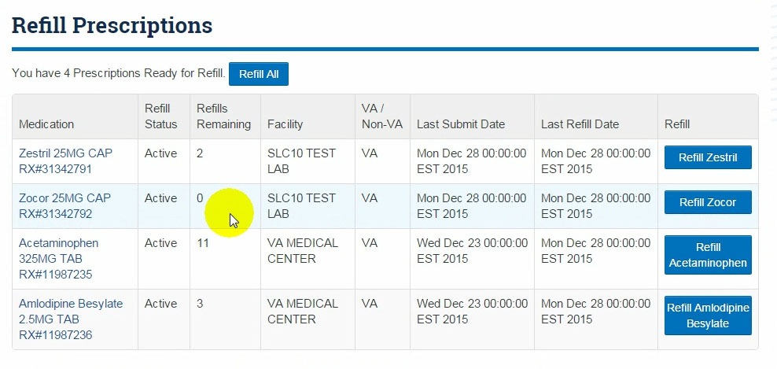

Figure : No authorization info listed

This issue was rated “Serious” due to a high percentage of users being unaware of the new authorization functionality. This may cause users to continue previous practices such as sending Secure Messages or calling their provider when a medication reaches zero.

**Recommendation(s):** HFE recommends performing a Quick Study to obtain additional insight into the ideal solution to the issue. During discussions of the issue with participants a number of remedies were suggested, but there is not enough information available to choose an ideal solution. If additional quick studies are unable to be performed, the simplest solution would be to add a canned statement regarding the new process, along with an asterisk or red text to draw the user’s attention to the change.

1. **Difficulty finding the “Compose” button on Secure Messaging page:** Participants in 5 out of 17 sessions (29%) had difficulty quickly finding the “Compose” button on the Secure Messaging page.
   1. Scrolls up/down looking for Compose button.
      1. P6: *"Make it red? Possibly 'New Message' instead of 'Compose'?"*
   2. Though already in Inbox, clicks Inbox to compose message.
      1. P9: *“I need to go to INBOX to send a message.”*
   3. Clicks away from Secure Messaging to Dashboard.
   4. From Secure Messaging page, uses top navigation to Messages > Compose Message.

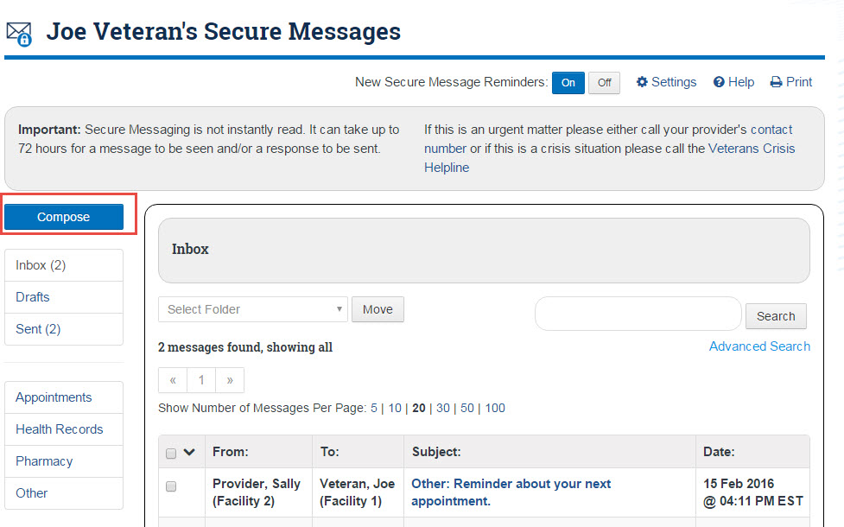

Figure : Compose button

This issue was rated “Serious” due to the task being important to the primary function of Secure Messaging. Users unaware of the transition from “New Message” to “Compose” may send faulty messages, causing delays for both providers and the users.

**Recommendation(s):** HFE recommends performing a Quick Study to look more in depth into the ideal positioning for the “Compose” button. Further, while “Compose” is standard with common email clients, the current version of MHV uses a “New Message” button. Quick Study results influenced the change to “Compose”, but familiarity with the current interface may have skewed task results slightly with participants seeking “New Message” instead.

1. **Difficulty finding the last kept appointment:** Participants in 15 out of 17 sessions (88%) had issues with finding the correct last kept appointment under Past Appointments.
   1. User selects early/first item on page 1, from 1 year in the past.
   2. User navigates away from Appointments page to Dashboard > Health Calendar.
   3. User navigates away from Appointments page to Dashboard > Health Summary.
   4. User navigates away from Appointments page to Dashboard > Health Records. 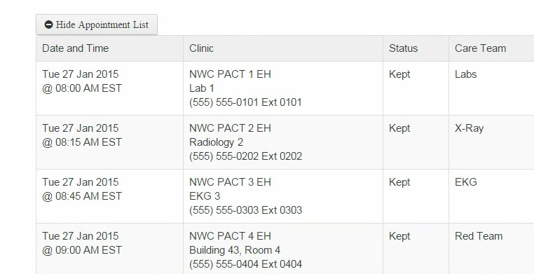

Figure : Appointment “Past” sorting

This issue was rated “Serious” due to the high task failure rate, in addition to high levels of confusion and frustration exhibited by participants.

**Recommendation(s):** HFE recommends reversing the order in which “Past” appointments are displayed. Currently, the Past appointments are displayed farthest back to most current, which is the opposite of industry standards and contrary to user expectations. Although the issue had a high occurrence rate, HFE feels it was a skewed finding due to the first Past appointments page displaying dates just prior to the testing day, but in 2015 instead of 2016. This led to participants falsely assuming they had found the correct appointment.

1. **Difficulty finding the last cancelled appointment:** Participants in 7 out of 17 sessions (41%) had an issue with finding the correct last cancelled appointment under Past Appointments.
   1. Clicks away from “Past” to “All” filter.
   2. Opens (“View Appointment”) multiple kept appointments and reviews information.

This issue was rated “Serious” due to its direct relation to Issue #3, in addition to high levels of confusion and frustration exhibited by participants.

**Recommendation(s):** HFE recommends reversing the order “Past” appointments are displayed. Currently, the Past appointments are displayed farthest back to most current, which is the opposite of industry standards and contrary to user expectations. Participants performed better on this task over the initial “Past” appointments task as they were forced to navigate to the second page of appointments, at which point some noticed the oddity in the sorting of the appointments. The issue of Past to Current sorting, however, still led a few participants to falsely assuming they had found the correct appointment.

1. **Participant successfully navigating through past appointments pages, but still choosing the wrong appointment to fulfill the task:** Participants in 8 out of 17 sessions (47%) mistakenly selected the wrong appointment, assuming they finished their task successfully.

This issue was rated “Serious” due to it being the primary cause of failure in the Appointment tasks and its direct relation to Issues #3 and #4 for the study.

**Recommendation(s):** HFE recommends reversing the order in which “Past” appointments are displayed. Currently, the Past appointments are displayed farthest back to most current, which is the opposite of industry standards and contrary to user expectations.

1. **Participants confused by “All” sorting under appointments:** Participants in 3 out of 17 sessions (18%) had issues with the All sorting following the same scheme as the Past sorting.
   1. Recommend that “All” should be arranged from latest to earliest.

This issue was rated “Serious” due to its relation to Issues 3, 4, and 5. The sorting displayed on the All pages started with appointments farthest back in the past, causing confusion among participants.

**Recommendation(s):** HFE recommends performing a Quick Study to determine the worth of the “All” section and possibly removing it entirely. While a Calendar view works for viewing all (previous and upcoming appointments), the concept is entirely lost in the “List” view, where there is no ideal way to show previous and future appointments simultaneously.

1. **Users confused by meaning of “Check Files” button on final Blue Button page:** Participants in 6 out of 17 sessions (35%) experienced issues upon reaching the final Blue Button page, as the processing never finished and they had to press a “Check Files” button.
   * 1. P6: *"[I know people] who will end up in a closed loop with that [‘Processing’ on the] screen. It’s more endemic to this demographic [Veterans]."*
   1. Comments that files should auto-populate rather than require clicking “Check Files”.
      1. P5: *"It was kind of confusing at that point because I had already clicked 'Next' to get them."*
   2. User clicks away using “Back to Health Records” button.

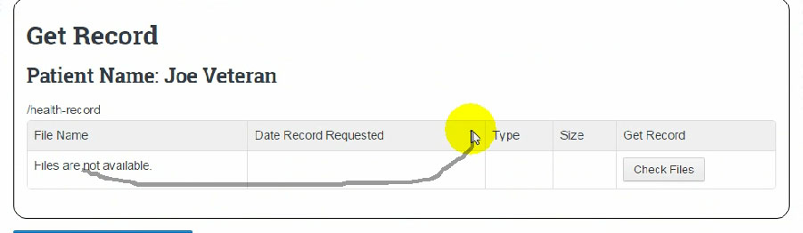

Figure : “Check Files” button

This issue was rated “Serious” due to the issue causing a high amount of confusion and potential task failure (task failure was avoided primarily due to moderator intervention at this point).

**Recommendation(s):** HFE recommends adding a message to inform users that the page is currently processing their results, in addition to informing the user to press “Check Files” to populate their Blue Button files. This may have been an issue with the test environment and the finding may be invalidated with a live working page.

1. **Difficulty proceeding beyond the initial page of Blue Button:** Participants in 4 out of 17 sessions (24%) experienced confusion at the initial Blue Button page and were unaware of how to continue.
   * 1. P6: *"'Next' means nothing… [People] are going to lose their minds on that."*
     2. P13: *"I don't know what to do."*
   1. Navigates away to Health Records > Track My Personal Health.
   2. Navigates away to Health Records via bread crumb, clicks Health Summary and Share Records.
   3. Waiting for “Update” to complete.

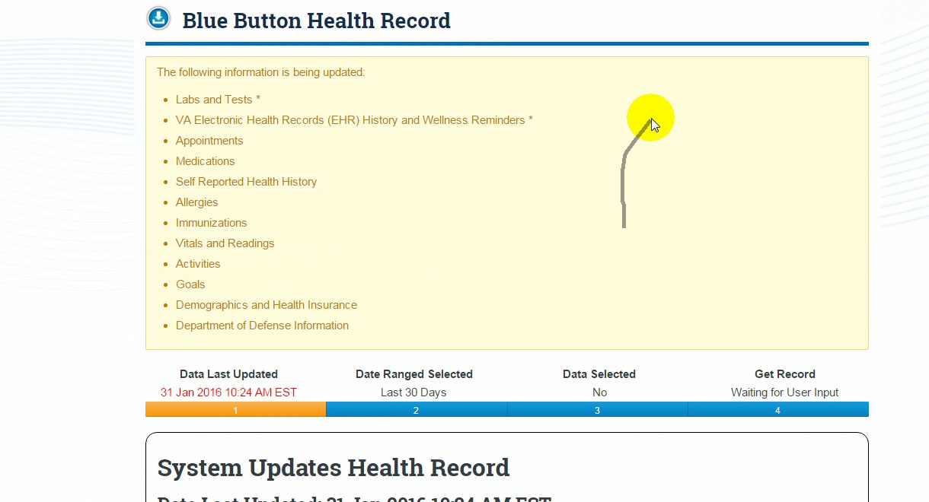

Figure : Initial Blue Button page

This issue was rated “Serious” due to the potential of complete task failure, in addition to the high amount of confusion and frustration caused by the page.

**Recommendation(s):** HFE recommends redesigning the initial Blue Button page to better inform users of the update that is occurring and the purpose. Users should be informed that they can manually refresh to process the update and should also be informed that they can continue without waiting. Currently, the user only receives a message telling them to use the “Next” button to continue after the page has finished updating. This may have been an issue with the test environment and the finding may be invalidated with a live working page.

1. **Difficulty navigating to Blue Button:** Participants in 5 out of 17 sessions (29%) had issues with navigating to the Blue Button Health Record section.
   * 1. P6: *"’Blue Button’ is stupid. They need to fix that...Nobody knows what Blue Button is."*
   1. Navigates to “Get Care/Health Calendar while looking for Blue Button.
   2. Navigates to “Get Care/Appointments” while looking for Blue Button.
   3. Clicks “Blue Button Features” within Blue button section.
   4. Clicks on information link on homepage sidebar.
   5. Navigates to “Track Health” while looking for Blue Button.
   6. Doesn’t see “continue” button at bottom of blue button entry page.
   7. Clicks on CCD features within Blue Button section.
   8. Considers that the Blue Button is any blue button, like the Search button.
      1. P6: *"Ok, I have no clue what Blue Button is. That would be 'Search', because that's the only blue button I see."*



Figure : The “Blue Button” participants saw

This issue was rated “Serious” due to the high levels of confusion and frustration associated with the task, in addition to participants being unaware of what “Blue Button” actually represented.

**Recommendation(s):** HFE recommends adding additional clarification explaining how Blue Button differs from other health records for users. The name of “Blue Button” also raises some concern, as it has no relation to self-health records and frequently confused users when they were trying to find it. In the previous version of MHV there was a visual “blue” button to accompany the name. With this no longer being the case a potential name or visual re-work may be in order.

## Medium Impact Issues

1. **Difficulty finding login fields:** Participants in 3 out of 17 sessions (18%) had difficulty locating the text entry fields for username and password on the “Login” page.
   1. Clicks on “Login” breadcrumb on Login page.
   2. Clicks on “Login” button on Login page.

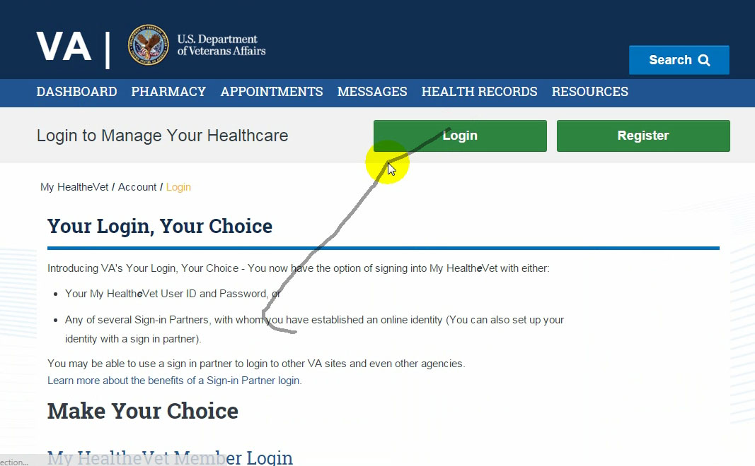

Figure : Login fields not visible without scrolling

This issue was rated “Moderate” due to the potential of task failure, resulting in failure of all following tasks.

**Recommendation(s):** HFE recommends moving the login entry fields to the right or above the informative text. This will ensure the text entry fields are noticed but still provide the user with informative text should they need it. Additionally, the “Login” button should not appear on the Login page, as the user is already on that page.

1. **Difficulty determining which Rxs are refillable:** Participants in 6 out of 17 sessions (35%) experienced difficulty in determining which meds were refillable.
   * 1. P6: *“It’s not clear though…But if there was a column for ‘Okay to refill.’ The top [note] is OK, but you’re actually looking for the content.”*
2. Clicked “Refresh” upon entering Rx Refill page and was presented with ALL medications.
3. Successfully accesses Rx Refill page but fails to notice "You have 4 Prescriptions..." note.
4. Believes Refill “0” means cannot be refilled.
   * 1. P4: *"Why would it be 4 if this [prescription has zero refills]?"*
     2. P4: *[after being shown authorization message]* *“If it says zero I would stop.”*
     3. P18: *"Well, it's 3 obviously."*
5. Doesn’t realize that prescriptions eligible for refill can be found on page called “Refill Prescriptions”.
6. From list of All Medications, believes all can be refilled.
7. Determined number of refills based on checkbox suggestions after clicking to refill random prescription.



Figure 9: Difficulty determining which prescriptions are refillable

This issue was rated “Moderate” due to the high confusion associated with the task, despite participants still successfully accomplishing the objective.

**Recommendation(s):** HFE recommends a Quick Study to further investigate the ideal solution to informing participants of when refills are available. While participants were still able to successfully submit refills, the large amount of confusion regarding which were refillable suggests room for improvement. This also relates to issue #1, as many participants assumed the medication at zero was ineligible for refill.

1. **Comments regarding “To” column on Secure Messaging:** Participants in 1 out of 17 sessions (6%) commented that there should not be a “To” column under Secure Messaging.
   * 1. P13*: "Why do you have 'To' on here? It is in my e-mail."*

This issue was rated “Moderate” due to the issue causing potential confusion among future users, in addition to the column being an unnecessary and redundant feature.

**Recommendation(s):** HFE recommends removing the “To” column entirely. The column is unnecessary.

1. **Comments regarding opening a message:** Participants in 2 out of 17 sessions (12%) tried to select or commented that you should be able to select anywhere on a message to open it.

This issue was rated “Moderate” due to the lack of accessibility and the conflict with leading industry standards.

**Recommendation(s):** HFE recommends allowing users to click anywhere on a message to open it as to be consistent with industry standards regarding email and messaging.

1. **Issues with selecting checkboxes on Secure Messaging:** Participants in 5 out of 17 sessions (29%) tried to open a secure message by clicking the checkbox to the left of the message.
   * 1. P6: *"Why'd I check that? I guess, working with geriatrics...they're gonna check that [box]."*

This issue was rated “Moderate” due to general confusion regarding the purpose of the check box.

**Recommendation(s):** HFE recommends removing the check box and “Folder” system completely. The Folder system in general is counter-intuitive when considering the purpose and short-term nature of the Secure Messaging system, thus making the checkbox to move messages unnecessary.

1. **Issues locating “Past” filter button:** Participants in 8 out of 17 sessions (47%) experienced difficulty finding the “Past” filter button.
   1. Recommends filter buttons placed near page header.
      1. P7: *"I think past and future [buttons] should be [at top near page header]."*
   2. Stuck on Appointments – Day page, no Future / Past / All buttons. Clicks on “Previous Day”.
   3. Stays on Future Appointments page, clicks on individual appointments to review.

This issue was rated “Moderate” due to the high percentage of participants that experienced difficulty with the task.

**Recommendation(s):** HFE recommends performing additional quick studies to better evaluate the ideal position of the filter options under Appointments. While the previous Quick Study looking at this was inconclusive, it should be noted that multiple participants recommended the filter options be moved to the top of the screen.

1. **Issues selecting wrong filter button:** Participants in 3 out of 17 sessions (18%) selected the wrong filter button set.
   1. Clicks “Day” filter by accident.
   2. Clicks “Day” “Week” or “Month” filter on purpose.
   3. Clicks “Day” filter after successfully navigating to “Past Appointments”.

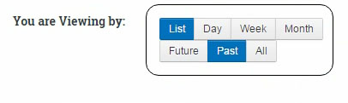

Figure 10: Filter buttons on Appointments

This issue was rated “Moderate” due to the difficulty displayed using the filter button set while attempting to locate past appointments.

**Recommendation(s):** HFE recommends performing additional quick studies to better evaluate the ideal position of viewing filters (List/Day/Week/Month) under Appointments. Additionally, it may be better to separate the “View” filters from the Future/Past filters for clarity.

1. **Unnecessary user intervention on Blue Button:** Participants in 3 out of 17 sessions (18%) selected “Check Updates” on the first page of the Blue Button process.

This issue was rated “Moderate” due to the requirement for user intervention to successfully be informed that they could continue the task.

**Recommendation(s):** HFE recommends having the updates automatically process on the initial Blue Button page while providing the user with a tilling wheel and message informing them to wait momentarily. Currently, there is no context surrounding the “Check Updates” button, leaving users to guess whether clicking it will have an effect.

1. **Hesitation on Blue Button data selection:** Participants in 2 out of 17 sessions (12%) experienced difficulty proceeding beyond the Blue Button data selection page.
   1. User hesitant about “Next” button.

This issue was rated “Moderate” due to the potential of task failure associated with lack of selecting the “Next” button.

**Recommendation(s):** HFE recommends adding additional context into the Blue Button process to inform users of the general flow (i.e. “Press “Next” at the bottom of the page after you’ve made your data selections.”)

1. **Confusion regarding Blue Button purpose:** Participants in 1 out of 17 sessions (6%) experienced confusions about the meaning and purpose of Blue Button.
   1. Identifies selections under Track My Personal Health (Labs, Vitals, etc.) as target data.
   2. Comments that they would not have clicked Blue Button to download data unless task had asked them to do so.
      1. P8: *"The Blue Button health record...I've never used it before...Other than reading the prompt of what it was asking for because of the task..."*

This issue was rated “Moderate” due to the lack of confusion regarding functionality and purpose behind Blue Button.

**Recommendation(s):** HFE recommends adding additional clarification explaining the purpose and usage of Blue Button.

1. **Issues selecting Date Range on Blue Button:** Participants in 2 out of 17 sessions (2%) recommended ways to change the “Date Range Selected” value on Blue Button.
   * 1. P4: *"I want to change that to 90 days."*
     2. P6: *"Absolutely...'Click here to select Date Range.'" (re: whether he thinks you should be able to click on it.)*
     3. P6: *"I'm looking for 90 [days]. I need that resolution before I move forward."*

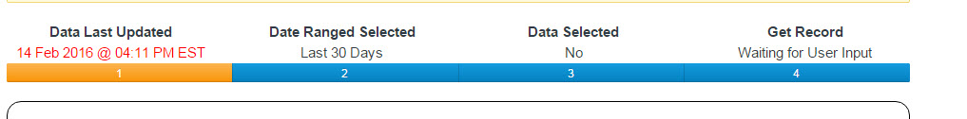

Figure 11: Progress Bar for Blue Button

This issue was rated “Moderate” due to the potential for task failure and confusion related to the date selection mechanism with Blue Button.

**Recommendation(s):** HFE recommends allowing users to change the date from the progress bar located at the top of the Blue Button pages, in addition to explaining that they can select it on the second page of the process. This issue may become null with a rework of the Blue Button process as a whole.

1. **Issues with length of Blue Button process:** Participants in 2 out of 17 sessions (12%) commented on the length of the Blue Button process being too long.
   * 1. P10: *“I think there’s too many screens…It takes a few to get there.”*
     2. P11: *"Blue Button seems busy. Just too much to read, reminds me of doing taxes."*

This issue was rated “Moderate” due to frustration expressed by users with the Blue Button process.

**Recommendation(s):** HFE recommends simplifying and reworking the flow of the Blue Button process. Currently, it is broken up into four separate steps which participants considered overbearing for the simple nature of the task.

## Low Impact (Minor) Issues

1. Immediately scrolls down past intro text to log in fields. (65% of participants)
2. Difficulty navigating to prescription refill. (18% of participants)
3. Confused by the checkboxes showing the other available prescriptions. (24% of participants)
4. Remarks that the medication in cart (small black text on gray background) is difficult to read. (6% of participants)
5. Fails to determine how many refills remaining on Acetaminophen after confirmation of order (“You have X refills remaining”). (6% of participants)
6. Difficulty reading the Refill Confirmation message. (6% of participants)
7. Doesn’t select topic medication. (6% of participants)
8. Doesn’t type in a subject while sending a message. (18% of participants)
9. Type message under auto-signature. (6% of participants)
10. Tries to hit “Past” a second time to look further into the past. (6% of participants)
11. Recommends change on filter button names. (6% of participants)
12. Comments that there should be a “Cancelled” filter. (12% of participants)
13. Attempts to click on bulleted items under “The following information is being updated:” (6% of participants)
14. Considers "Share Records" link on "Health Records" screen is part of BB data download process. (6% of participants)
15. Hesitates over which blue button download to view/download. (6% of participants)
16. Comments that the Next buttons should be changed. (6% of participants)
17. Difficulty finding medical information (cataracts). (12% of participants)

## Strengths

1. Confidently finds “Login” button. (94% of participants)
2. Notices / verbally mentions red “4” indicator. (18% of participants)
3. Likes the checkboxes showing the other available prescriptions. (47% of participants)
4. Remarks on / notices refills remaining on refill confirmation page. (53% of participants)
5. Quickly / confidently finds “Go to Secure Messages” link. (71% of participants)
6. Confidently changed subject to medication. (88% of participants)
7. Clicks “Refresh” upon entry to Future Appointments page. (6% of participants)
8. Easily identified the clinic phone number. (59% of participants)
9. Finds Clinic phone number after clicking “View Appointment” on appointment details page. (35% of participants)
10. Uses numbered page navigation to find more appointments. (76% of participants)
11. Uses “show number of appointments per page” to find appointment. (12% of participants)
12. Uses “Next” button to find more appointments. (6% of participants)
13. Confidently finds “Blue Button Download” under Health Records. (59% of participants)
14. Uses Blue Button icon or link on Health Records page. (6% of participants)
15. Confidently finds “Veterans Health Library” starting at top navigation “Resources”. (35% of participants)
16. Confidently finds “Veterans Health Library” under “Resources” content box. (18% of participants)
17. Confidently finds “Veterans Health Library” graphic button. (12% of participants)
18. Comments on big fonts. (12% of participants)
19. Site is easy to use. (18% of participants)
20. Comments on differences in page content. (29% of participants)
21. Comments on new dashboard navigation. (35% of participants)
22. Comments positively on Blue Button name. (6% of participants)

## Not Applicable

1. Comments on the non-necessity of checkboxes / moving messages to folders. (6% of participants)
2. Uses breadcrumb to return to Appointments – Future page. (6% of participants)
3. Comments that the Past appointment dates should be presented in reverse order. (35% of participants)
4. Uses MHV Search button. (12% of participants)
5. Types in a general search term rather than “Cataracts”. (6% of participants)

# User Performance Measures

User performance measures are reported in the table below. Please note that, because of the small sample size, statistical significance cannot be inferred. Detailed performance data are provided in Appendix B: Detailed Performance Data.

* Effectiveness - Objective measures of task success and task failures.
* Efficiency – Objective measures of time on task and number of clicks to complete each task.
* Satisfaction – Subjective measures that express user satisfaction with the ease of use of the site.

|  |  |  |  |
| --- | --- | --- | --- |
| **Acceptable?** | **Measure** | **Value** | **Units (averages across all tasks)** |
| **Effectiveness** |  |  |  |
| Yes | Effectiveness: Task Success | 64% | Ratio of Task Success (# of successes/# of attempts). |
| Yes | Effectiveness: Task Success (Task Time) | 124% | Ratio of Task Time to Benchmark Time (observed time/benchmark time for tasks completed successfully). |
| Yes | Effectiveness: Task Failure | 36% | Ratio of Task Failure (# of failures/# of attempts). |
| **Efficiency** |  |  |  |
| Yes | Efficiency: Task Time | 124% | Ratio of Task Time to Benchmark Time (observed time/benchmark time for tasks completed successfully) |
| **Satisfaction** |  |  |  |
| Yes | Satisfaction: SUS | 82.5 | System Usability Score. |

Table : Performance Measures Overview

# **Satisfaction**

Participants completed the System Usability Scale (SUS) questionnaire (see Appendix E) at the end of their sessions. The SUS is a reliable and valid measure of system satisfaction. SUS scores range from 0 – 100. Sauro reports that the average SUS score from 500 studies across various products (e.g., websites, cell phones, enterprise systems) and across different industries is a 68. A SUS score above a 68 is considered above average and anything below 68 is below average. Broadly interpreted, scores under 68 represents systems with below average usability; scores over 68 would be considered above average.

The SUS questionnaire measures “perceived ease-of use,” when taken directly after testing or exposure to its subject. It is the participant’s “subjective view of the usability of the system.” It is a measure of the sentiment toward the system, not the objective experience. Participants can and will rate something as easy after consistently failing tasks. As such, the SUS is not diagnostic and should not be taken out of context of the other usability metrics collected during testing.

Based on the SUS findings collected during the usability test session, subjective satisfaction with the system (based on performance of tasks in the session) was **82.5 (SD=6.7).** Scores ranged considerably from test to test and there were five outliers, with extremely low and extremely high SUS scores. The SUS score, including these outliers, was 81.6 (SD=13.3). **This SUS score indicates an above average satisfaction ranking.**

Figure 12: System Usability Scale (SUS) scatter plot

The SUS scores were examined against participant demographics to determine if self-assessed familiarity with desktop computers and/or usage of the MyHealth***e****V*et website correlated with the participants’ level of satisfaction with the site.

|  |  |  |  |
| --- | --- | --- | --- |
| **Session/Participant** | **SUS Score** | **How often do you use MyHealtheVet?** | **What is your level of familiarity with using a Desktop computer?** |
| Session 2 | 87.5 | Rarely or Never | Advanced |
| Session 3 | 87.5 | Weekly | Advanced |
| Session 4 | 77.5 | Rarely or Never | Intermediate |
| Session 5 | 97.5 | Weekly | Advanced |
| Session 6 | 50 | Monthly | Intermediate |
| Session 7 | 82.5 | Rarely or Never | Basic |
| Session 8 | 82.5 | Rarely or Never | Intermediate |
| Session 9 | 77.5 | Monthly | Basic |
| Session 10 | 87.5 | Monthly | Intermediate |
| Session 11 | 72.5 | Weekly | Advanced |
| Session 12 | 82.5 | Rarely or Never | Intermediate |
| Session 13 | 55 | Rarely or Never | Intermediate |
| Session 14 | 95 | Rarely or Never | Intermediate |
| Session 15 | 90 | Rarely or Never | Intermediate |
| Session 16 | 100 | Rarely or Never | Basic |
| Session 17 | 92.5 | Monthly | Advanced |
| Session 18 | 70 | Weekly | Intermediate |

Table : SUS Score and Technology/MHV familiarity comparison

The participant SUS scores do not seem to correlate to their familiarity with desktop computer usage, nor do they correlate to their frequency of My Health***e***Vet use. This would indicate a high level of usability for first-time as well as returning users.

# Perceived Utility

Figure 13: Did the My HealtheVet website meet your expectations?

One of the measures captured was user perspectives regarding the utility of the MHV task functions. To the question of whether the website met their expectations, all 17 participants answered “Yes.” For those who provided additional comments, opinions were consistent.

* P2: *“Oh yes. [It is] really good.”*
* P5: “*Everything is here. If a veteran had not used a specific tool before, he/she might have a little trouble at first, but if they look around, it's all there.”*
* P6: *“Solid. Bulletproof. Clear. Concise. Readable.”*
* P8: *“Ease of use is important, and overall, the website is designed really well.”*
* P10: *“Above and beyond my expectations but I didn't use it to its potential at all.”*
* P16: *“Exceeded expectations.”*
* P17: *“Exceeded expectations.”*
* P18: *“It does, allows me to have a better grip on what’s happening.”*

Note that the preceding question did not address comparisons to the current (previous) version of MyHealth***e***Vet. This was explored in a later question.

Figure 14: Do you feel the content of the website could be useful to you?

When asked whether they felt the My Health***e***Vet website could be useful to them, participants unanimously replied “Yes.” Their comments in response to the question elaborated on their positive feelings, but a few reservations did appear:

* P2: *“Positively.”*
* P3: *“It is a lot better than the old MyHealth****e****Vet.”*
* P4: *“Consolidat[ing] medical records is useful.”*
* P5: *“There were things that I hadn't done on the site before that I did today, and I know now that I can search within the site for different health needs.”*
* P6: *“Absolutely.”*
* P8: *“It would be a destination I could go to get information related to Veteran health benefits.”*
* P11: *“A lot more than all the garbage on the current. [The current site] looked like someone was doing work just to justify their job. Much too busy.”*
* P13: *“To me, yes, but not to everyone. Some things could be at a bigger font.”*
* P15: *“Absolutely, would definitely use the site now.”*
* P16: *“Absolutely.”*
* P18: *“Sure, if you use it.”*

Figure 15: Would you recommend the My HealtheVet website to other Veterans?

When asked whether they would recommend the site to other Veterans, participants again responded positively, with all participants responding “Yes.”

* P2: *“I have always recommended Veterans use this site, because it is so easy to get information about scripts, and to refill scripts without waiting on the phone.”*
* P8: *“It's easy to use.”*
* P15: *“Absolutely. Would be really helpful for my current job.”*
* P16: *“Yeah and I don't really recommend anything. Veterans are always looking out for each other.”*
* P18: *“Absolutely. It's a very useful tool to help manage your health care at the VA.”*

Overall, participants are very certain of the utility of the My Health***e***Vet website. Their overwhelmingly positive answers are notable considering their low task success rates on tasks such as Appointments and Blue Button. While the former low task success rates were mostly unknown to the participants, those for the Blue Button were pronounced and much commented on. Participants believe the site to be useful and necessary, and consider the obstacles to success on the aforementioned tasks to be relatively easy to fix.

# **Limitations**

Due to the challenges of using test accounts and data in a prototype personal health record website, there were several limitations for this study. In some instances these limitations contributed, in varying degrees, to issues that had impact on task success.

## General Study Design Limitations

Users were directed to return to the My Health*e*Vet home screen between task focus areas. This was done to enable easier A/B comparisons to the previous design of the site, which had a different navigation structure. Users in the 2015 baseline study were also directed to the homepage between tasks. Due to this study design, participants may have used different navigation or more natural strategies than those of the story-line based script. This study design limitation did not contribute to any issues noted in this report.

## Appointments Test Data Limitations

The setup of test data likely contributed to the high failure rate of the second and third Appointments tasks (dealing with past appointments).

As noted in the findings, past appointment test data was presented with earliest dates first. As the earliest dates were close to one year in the past (e.g. February 1, **2015**), users noticed a month and day similar to the current date, and assumed this was a recent date. Although this was a built-in limitation of the data, such a scenario could exist in a real-life situation, so HFE’s findings and recommendations on date presentation order still apply.

## Blue Button Test Data Limitations

In the test environment, the final page of the Blue Button download process presented users with a “Check Files” button instead of “Download Buttons.” It was unclear to users whether this situation was a transient one (i.e. to be followed by an automatic refresh), or one always requiring action.

## Veterans Health Library Test Data Limitations

The built-in MHV search feature was not functioning at the time of testing. However, only two (2) users out of 17 tried to utilize (and were subsequently unable to use) this feature to perform the VHL task.

# Conclusion

The redesigned prototype of My Health***e***Vet scored moderately high in effectiveness and above average in satisfaction. The task success rate was high at 64% (as compared with 44% for the 2015 baseline study), with participants failing 36% of all tasks attempted. Participants failed 29 out of the total 170 tasks performed (over the course of 17 sessions) due to exceeding the task time success threshold (benchmark time + 100%). Participants who did succeed did so 24% slower than the benchmark time, which is acceptable. Comparied to the 2015 benchmark time, participants in 2016 succeeded 6% slower than the time, a significant improvement.

The site received an above average SUS score of 82.5, a very high indicator of participants’ satisfaction with the site. In 2015, the previous version of the site scored 64.7. Although the score in the most recent test was well above the average SUS score of 68, this should also be considered in light of the participants’ high failure rate on the Appointments and Blue Button tasks. As noted in the perceived utility section, participants consistently rated the site high for meeting expectations and likeliness to use, which would indicate that despite flaws which prevented users from successfully completing some tasks, the overall function and mechanics of the website are acceptable.

The login process, typically a simple process but decidedly difficult to complete on the previous MHV site, has been brought up to standards, with 100% success versus 40% recorded in the 2015 study. While some minor usability issues need to be corrected (login button still appearing on the login page, unnecessary scrolling required to get to text fields), the redesign is a large improvement over its predecessor.

The prescription refill process scored similarly to the 2015 study in some ways, differently in others. As in the earlier study, users had difficulty identifying prescriptions eligible for refill, even though the redesign provides multiple cues for clarity. As suggested by participants, simple added language and/or a button change may clarify eligibility of items which require authorization. The refill process itself was much improved, with an 88% success rate versus 40% in 2015.

As mentioned, user expectations with regard to the presentation of past appointment data contributed to near total failure on the past appointment selection tasks. Performance in this section improved on the following task, past cancelled appointments, as some users came to notice the unusual ordering of the appointments. HFE recommends further testing of the appointments page with varying placements of the date filter buttons and reversal of the date order for past appointments.

The length and wordiness of the Blue Button process were points of contention among users. Inability to progress past the first page was caused by distraction by “you-are-here” graphic elements, unclear instructions, and ambiguous button functions.

The dashboard itself, particularly the new navigation buttons, earned high praise from users. Participants appreciated the larger fonts, clear & easy-to-find buttons for common tasks, and a focus on actionable content versus magazine-style articles.

In summation, while the new prototype for MHV greatly outperformed the previous site, there are still a number of areas in need of improvement. The presentation of data for the Appointments and Blue Button sections in particular may have influenced the high failure rate in those areas. With additional quick studies to evaluate areas of uncertainty and presentation changes in the aforementioned areas, it is expected that upon completion, the MHV redesign will be a resounding success.

# Appendix A: Participant Demographics and Background Information

Participant demographics are reported in the table below.

|  |  |  |  |  |  |
| --- | --- | --- | --- | --- | --- |
| **Participant** | **Gender** | **Age Range** | **How often do you use My HealtheVet?** | **What is your level of familiarity with using a Desktop computer?** | **Assistive Technology Needs** |
| Session 2 | Male | 60s | Rarely or Never | Advanced | No |
| Session 3 | Male | 40s | Weekly | Advanced | No |
| Session 4 | Female | 40s | Rarely or Never | Intermediate | No |
| Session 5 | Male | 40s | Weekly | Advanced | No |
| Session 6 | Male | 50s | Monthly | Intermediate | No |
| Session 7 | Male | 60s | Rarely or Never | Basic | No |
| Session 8 | Male | 30s | Rarely or Never | Intermediate | No |
| Session 9 | Female | 50s | Monthly | Basic | No |
| Session 10 | Male | 50s | Monthly | Intermediate | No |
| Session 11 | Male | 40s | Weekly | Advanced | No |
| Session 12 | Male | 20s | Rarely or Never | Intermediate | No |
| Session 13 | Female | 60s | Rarely or Never | Intermediate | No |
| Session 14 | Male | 60s | Rarely or Never | Intermediate | No |
| Session 15 | Female | 40s | Rarely or Never | Intermediate | No |
| Session 16 | Male | 30s | Rarely or Never | Basic | No |
| Session 17 | Male | 40s | Monthly | Advanced | No |
| Session 18 | Male | 70s+ | Weekly | Intermediate | No |

# Appendix B: Detailed Performance Data

Complete data collected during the sessions and/or generated via analysis, may be found in the master data workbook:



This workbook includes:

* Results Summary for all successful attempts.
* Summary of metrics by task.
* Table of total HFE standard metrics.
* Total task success metrics, and task success metrics broken down by success criteria and success time.
* Task times and calculations of task time success threshold.
* Complete findings (weaknesses and strengths) along with frequency in the form of a “Problem by Session” matrix (as marked from manual notes and Morae™ recordings).
  + The findings were compiled into the “problem by participant (or session) matrix”[2] in order to analyze frequency, with the sessions on the x axis and the issues listed on the y axis. Issues on the y axis are listed in descending order of frequency. When issues were repeated by participants during the same focus group, the number of times the issue was encountered is included in the corresponding cell.
* Problem by task metrics.
* Performance charts (task success, task time, mouse clicks) for success only and all attempts.
* Charts displaying questionnaire data (opening, post-task and closing).
* Raw questionnaire answers (opening, post-task and closing).
* Raw SUS scores, SUS calculations, scatter plot and comparison table by desktop and MHV use.
* Participant demographics.

If you would like help interpreting any of the data contained in the Master Data Workbook, please contact the study authors for a walkthrough session.

# Appendix C: Study Scripts

### Introduction

Thank you for your interest and willingness to provide feedback on My Health***e***Vet and its various components. For the past few months, a redesign of My Health***e***Vet has been underway. The goal of today’s session is to test the redesigned website so that we can obtain an understanding of how easy it is to use and how satisfied Veterans are with it. Altogether, testing will take no more than 1 hour. I am your facilitator, William Plew, from Human Factors Engineering.

This is a test of the My Health***e***Vet website, not a test of your performance. The purpose is to discover the usability of the redesigned version of the website. There are no wrong answers to any of the questions. We appreciate any comments and if you have questions, feel free to ask, although I can’t help directly with the tasks.

Your participation is completely voluntary and you may withdraw at any time. Your feedback is kept confidential; your name will not be associated with any comments or results. Do you have any questions for me before we get started?

We would like to record today’s session. The recordings will be kept on a secure server with access provided only to project team members. Do we have your permission to record?

***\*\*Begin recording*: Actions -> Morae Recording & WebEx\*\***

Now that we’re on record, once again do I have your permission to record? Thank you. There will be three main parts in today’s test. First, we’ll begin with a brief questionnaire, then we’ll perform a few common tasks in My Health***e***Vet, and lastly we’ll wrap up with a short questionnaire and usability survey. There will be a few different key areas we’ll look at in today’s evaluation. You can start each task by clicking the Start Task button on the prompt up above. After you complete each task, please hit the End Task button and you will be asked a short question regarding the task. If at any time you need to view the instructions again you can use the Show Instructions button to expand or minimize them. Whenever you’re ready to begin, please click the Start button on the screen. Do you have any final questions before you begin?

***Participant to answer in Morae via an Opening Questionnaire:***

### Opening Questionnaire

*The following questions are included in the questionnaire presented via Morae.*

We will begin with some background questions about you. Please take your time and if you have any questions you are welcome to ask me for help.

You should see a questionnaire on the screen. Please complete it.

1. Gender: □ Male □ Female
2. Age Range: □ 20s □ 30s □ 40s □ 50s □ 60s □ 70s or older
3. How often do you use My Health***e***Vet? □ Daily □ Weekly □ Monthly □ Rarely or Never
4. Which task(s) do you commonly use My Health***e***Vet for: □ Prescription Refill □ Secure Messaging □ Appointments □ Blue Button □ Veterans Health Library □ Other:
5. What is your level of familiarity with the following technologies?
   1. Desktop □ Basic □ Intermediate □ Advanced
   2. Laptop □ Basic □ Intermediate □ Advanced
   3. Tablet □ Basic □ Intermediate □ Advanced
   4. Smart Phone □ Basic □ Intermediate □ Advanced
6. If familiar with Tablet or Smart Phone: Approximately how many mobile apps have you downloaded? (Open Answer)
7. Do you require any assistive technologies (e.g., a screen reader) when using a computer?

□ Yes □ No

1. If “Yes”, please describe:
2. Do we have your permission to record your voice and screen interactions? □ Yes □ No

All right, at this point the prompts will fully guide you through the exercise. I will be right here in the event that you need any technical help, but I cannot assist with navigation. Please take your time and complete the tasks at a pace that you’re comfortable performing.

Before we begin, I want to make sure you know the site you are about to interact with is a prototype, and may not reflect the final design and colors. However, the basic layout and navigation scheme are fairly representative of the final product.

***Participant will now proceed through and complete the MHV navigation tasks.***

*The following tasks and questionnaire prompts are included in the questionnaire presented via Morae.*

**Section 1: MHV Logon**

*Task:* You just remembered that you had a couple of tasks that need to be accomplished within My Health***e***Vet. Please go ahead and login to your account with the provided credentials.

*[2016 baseline time / 2015 baseline time]*

*Success Criteria (1:08 / 1:17):*

* From the main screen, clicks green LOGIN button and on the following screen enters username and password.
* Completes task within the allotted task time.

*Failure Criteria:*

* “Login” is never selected.
* Participant is unable to find the User ID/Password section.
* Participant exceeds the allotted task time.

*Questionnaire Prompts:*

* Please rate the difficulty of the task you just completed.
  + Very Easy – Easy – Neutral – Difficult - Very Difficult.
* Was there anything about this task that you found confusing or difficult? If so please elaborate.
  + Yes (Open-ended box added).
  + No.
* Did you find this task easier, the same, or more difficult to perform compared to the previous version of My HealtheVet?
  + Easier.
  + The same.
  + More difficult.
  + I have never performed this task before.

**Section 2: Rx Refill**

*Task:* You have been meaning to see if any of your medications are available for refill. Please determine if any meds are eligible for refill at this time and make sure to note how many are available for refill (if any).

*Success Criteria (0:37 / 1:20):*

* Successfully goes to “Refill Prescriptions” page (from Dashboard, clicks “Refill Prescriptions” OR goes to Pharmacy > “Refill Prescriptions” OR any other method).
* Indicates 4 medications are refillable.
* Completes task within the allotted task time.

*Failure Criteria:*

* ~~Infer from Dashboard indicator only?~~
* Inability to navigate to the sub-page.
* Inability to locate refillable medications.
* Exceeds the allotted task time.

*Questionnaire Prompts:*

* Did you find any meds that were eligible for refill? If so how many were eligible?
  + Yes (Open-ended box added).
  + No.
* Please rate the difficulty of the task you just completed.
  + Very Easy – Easy – Neutral – Difficult - Very Difficult.
* Was there anything about this task that you found confusing or difficult? If so please elaborate.
  + Yes (Open-ended box added).
  + No.
* Did you find this task easier, the same, or more difficult to perform compared to the previous version of My HealtheVet?
  + Easier.
  + The same.
  + More difficult.
  + I have never performed this task before.

*Task:* Please go ahead and request a refill for Acetaminophen and make sure to note how many refills are remaining after submitting your request.

S*uccess Criteria (1:01 / 0:26):*

* Selects the button “Refill Acetaminophen.”
* Clicks “Continue.”
* Clicks “Submit Order.”
* Indicates # remaining from notation on refill confirmation page **OR** goes to View Prescriptions to note remaining refills OR remembers refills. Properly notes the number of remaining refills.
* Completes task within the allotted task time.

*Failure Criteria:*

* Refills the incorrect medication.
* Fail to complete refill process.
* Reports the incorrect number of refills remaining.
* Exceeds the allotted task time.

*Questionnaire Prompts:*

* How many refills were remaining on the prescription?
  + (Open-ended).
* Please rate the difficulty of the task you just completed.
  + Very Easy – Easy – Neutral – Difficult - Very Difficult.
* Was there anything about this task that you found confusing or difficult? If so, please elaborate.
  + Yes (Open-ended box added).
  + No.
* Did you find this task easier, the same, or more difficult to perform compared to the previous version of My HealtheVet?
  + Easier.
  + The same.
  + More difficult.
  + I have never performed this task before.

***[If acetaminophen isn’t available for refill, ask the participant to refill a different medication that is available. If none are available, ask them how they think they would request a refill.]***

***“Considering what you just told me, how do you think you would request a refill from this page?”***

**Section 3: Secure Messaging**

*Task:* Please return to the My Health***e***Vet Dashboard before clicking Start Task.

Now that you’ve requested the refill, you wanted to touch base with the pharmacist regarding a new prescription that wasn’t on your Refill page. Check to see if you have any new messages from Dr. Douglas and open them if you do.

*Success Criteria (0:47 / 2:33):*

* Selects “Messages”, “Messaging” or “Go to Secure Messages” OR locates Secure Messaging page through the search function.
* In Inbox > Finds Dr. Douglas’s most recent message, recognizes bold message(s) as new.
* Opens Dr. Douglas’ message. *(FOR PTP: message should be un-bolded after being viewed).*
* Completes task within the allotted task time.

*Failure Criteria:*

* Inability to locate Secure Messaging.
* Never finds Dr. Douglas’s most recent message.
* Exceeds the allotted task time.

*Questionnaire Prompts:*

* Please rate the difficulty of the task you just completed.
  + Very Easy – Easy – Neutral – Difficult - Very Difficult.
* Was there anything about this task that you found confusing or difficult? If so please elaborate.
  + Yes (Open-ended box added).
  + No.
* Did you find this task easier, the same, or more difficult to perform compared to the previous version of My HealtheVet?
  + Easier.
  + The same.
  + More difficult.
  + I have never performed this task before.

***[If the message is not flagged as unopened, have the participant locate the most recent message from Dr. Douglas.]***

***“Next I’d like for you to navigate to messages and find the most recent message from Dr. Douglas.”***

*Task:*  You've decided that you want to send a new message regarding a prescription you’ve been waiting on. Compose a new message to the Facility Triage 3 and ask them about a new prescription for ibuprofen.

*Success Criteria (1:47 / 1:36):*

* Selects “Compose”.
* Selects provider team “Facility Triage 3”.
* Selects “Medications” as the Subject.
* Composes a message regarding the ibuprofen.
* Sends the message. Gets to success screen.
* Completes task within the allotted task time.

*Failure Criteria:*

* Inability to create a new message (cannot find “Compose” button).
* Inability to locate the correct clinic / provider team “Facility Triage 3”.
* Does not send the message.
* Exceeds the allotted task time.

*Questionnaire Prompts:*

* Did you update the subject line to Medication?
  + Yes.
  + No.
* Please rate the difficulty of the task you just completed.
  + Very Easy – Easy – Neutral – Difficult - Very Difficult.
* Was there anything about this task that you found confusing or difficult? If so please elaborate.
  + Yes (Open-ended box added).
  + No.
* Did you find this task easier, the same, or more difficult to perform compared to the previous version of My HealtheVet?
  + Easier.
  + The same.
  + More difficult.
  + I have never performed this task before.

**Section 4: Appointments**

*Task:* Please return to the My Health***e***Vet Dashboard before clicking Start Task.

Now that we’ve sent our message, let’s check appointments to see the next time you have a VA facility visit scheduled. You’ll want to find the clinic phone number for the visit as well.

**FOR PTP REFERENCE (note: “not applicable” was an error – should have read “future”).**

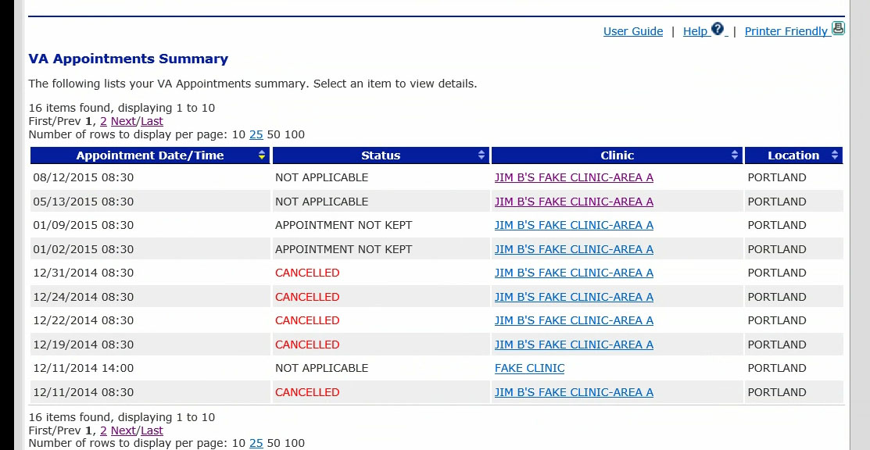

*Success Criteria (1:05 / 3:05):*

* Selects Appointments in top navigation bar or on Dashboard or via Search.
* Locates next upcoming appointment based on current date and whether appointment indicated as “Scheduled.”
* Locates Clinic Phone number.
* Completes task within the allotted task time.

*Failure Criteria:*

* Inability to navigate to Appointments page.
* Inability to find the next upcoming appointment.
* Failure to locate the Clinic Phone number.
* Exceeds the allotted task time.

*Questionnaire Prompts:*

* Did you find the clinic phone? Please type it in if you did.
  + Yes (Open-ended box added).
  + No.
* Please rate the difficulty of the task you just completed.
  + Very Easy – Easy – Neutral – Difficult - Very Difficult.
* Was there anything about this task that you found confusing or difficult? If so please elaborate.
  + Yes (Open-ended box added).
  + No.
* Did you find this task easier, the same, or more difficult to perform compared to the previous version of My HealtheVet?
  + Easier.
  + The same.
  + More difficult.
  + I have never performed this task before.

*Task:* Now, please determine the last time you visited a VA facility and note the date of the visit.

*Success Criteria (0:59 / 1:50):*

* User clicks “Past” filter. Locates last kept appointment *(first one listed on that page).*
* Completes task within the allotted time.

*Failure Criteria:*

* Inability to find the last confirmed appointment.
* Exceeds the allotted task time.

*Questionnaire Prompts:*

* Did you find the date of your last visit? Please type it in if you did.
  + Yes (Open-ended box added).
  + No.
* Please rate the difficulty of the task you just completed.
  + Very Easy – Easy – Neutral – Difficult - Very Difficult.
* Was there anything about this task that you found confusing or difficult? If so please elaborate.
  + Yes (Open-ended box added).
  + No.
* Did you find this task easier, the same, or more difficult to perform compared to the previous version of My HealtheVet?
  + Easier.
  + The same.
  + More difficult.
  + I have never performed this task before.

*Task:* [With your facilitator, confirm that you are now looking at a listing of your past appointments.]

Now find the most recent past CANCELLED appointment and note the date of that appointment.

*Success Criteria (0:59 / --):*

* User clicks “next” page or page “2” link. Locates last cancelled appointment *(on second page, the most recent appointment indicated as “Cancelled”).*
* Completes task within the allotted time.

*Failure Criteria:*

* Inability to go to second page of past appointments.
* Inability to find the most recent appointment indicated as “Cancelled.”
* Exceeds the allotted task time.

*Questionnaire Prompts:*

* Did you find the date of your last *past* cancelled appointment? Please type it in if you did.
  + Yes (Open-ended box added).
  + No.
* Please rate the difficulty of the task you just completed.
  + Very Easy – Easy – Neutral – Difficult - Very Difficult.
* Was there anything about this task that you found confusing or difficult? If so please elaborate.
  + Yes (Open-ended box added).
  + No.
* Did you find this task easier, the same, or more difficult to perform compared to the previous version of My HealtheVet?
  + Easier.
  + The same.
  + More difficult.
  + I have never performed this task before.

**Section 5: Blue Button**

*Task:* Please return to the My Health***e***Vet Dashboard before clicking Start Task.

In preparation for an appointment you have with a doctor in private practice, I’d like for you to navigate to Blue Button and download the following records for a range of 3 months: Future VA Appointments, VA Laboratory Results, VA Allergies, and VA Vitals and Readings. Please download the pdf version.

***Facilitator prompts to expand question for reference***

*Success Criteria (3:22 / 2:00):*

* Selects Blue Button Download on homepage OR Locates Blue Button page through search function.
* Selects 3 months date range.
* Selects specified items.
* After submitting query, selects “Check files.”
* After files appear, selects “Download” (either pdf or text).
* Completes task within the allotted task time.

*FOR PTP, add “you have successfully d/l’d file”indicator or pop-up*

*Failure Criteria:*

* Inability to navigate to Blue Button page.
* Failure to select appropriate date range.
* Failure to download specified criteria.
* Failure to “Check files.”
* Failure to “Download” file (either pdf or text).
* Exceeds the allotted task time.

*Questionnaire Prompts:*

* Did you set the date range to 3 months?
  + Yes.
  + No.
* Please rate the difficulty of the task you just completed.
  + Very Easy – Easy – Neutral – Difficult - Very Difficult.
* Was there anything about this task that you found confusing or difficult? If so please elaborate.
  + Yes (Open-ended box added).
  + No.
* Did you find this task easier, the same, or more difficult to perform compared to the previous version of My HealtheVet?
  + Easier.
  + The same.
  + More difficult.
  + I have never performed this task before.

**Section 6: Veterans Health Library**

*Task:* Please return to the My Health***e***Vet Dashboard before clicking Start Task.

You’re worried about your eyesight lately and want to do some research. Please find some information on cataracts on the MHV site.

*Success Criteria (2:06 / 2:27):*

* Selects Veterans Health Library > Selects Diseases and Conditions > Selects Eye Problems > Selects “What Are Cataracts?” OR Selects SEARCH
* Go to Resources page and go to VHL from there.
* OR, go to Resources and Medical Library and go to VHL from there.
* Locates the “What Are Cataracts” entry through searching.
* Completes task within the allotted task time.

*Failure Criteria:*

* Inability to locate the Veterans Health Library.
* Inability to locate the “What Are Cataracts?” entry.
* Exceeds the allotted task time.

*Questionnaire Prompts:*

* Please rate the difficulty of the task you just completed.
  + Very Easy – Easy – Neutral – Difficult - Very Difficult.
* Was there anything about this task that you found confusing or difficult? If so please elaborate.
  + Yes (Open-ended box added).
  + No.
* Did you find this task easier, the same, or more difficult to perform compared to the previous version of My HealtheVet?
  + Easier.
  + The same.
  + More difficult.
  + I have never performed this task before.

### Closing Questionnaire

*The following questions are included in the questionnaire presented via Morae and will immediately display after the completion of the task and PRIOR to the SUS test.*

#### Prompt that they can still view the site by moving the survey to the side.

You should now see a second questionnaire on the screen. Please complete the questionnaire.

1. What was your overall impression of the My Health**e**Vet prototype site?
2. Which section did you find it easiest to perform tasks in?

□ Login □ Prescription Refill □ Secure Messaging □ Appointments □ Blue Button

□ Veterans Health Library

Why?

1. Which section did you find the most difficult to perform tasks in?

□ Login □ Prescription Refill □ Secure Messaging □ Appointments □ Blue Button

□ Veterans Health Library

Why?

1. Were there any features that you were surprised to see?

□ Yes □ No

If Yes, what features were surprising?

1. Was there anything missing in this website?

□ Yes □ No

If Yes, what features would you like to have that you did not see?

1. In general, did the website meet your expectations?

□ Yes □ No

Why or why not? If no, what could be improved to change that?

1. Overall, do you feel the content of the website could be useful to you?

□ Yes □ No

Please elaborate why you feel that way.

1. Would you recommend this website to other Veterans? Please elaborate for us.

□ Yes □ Maybe □ No

1. What are your thoughts on the redesigned website as compared to the previous version of My HealtheVet?

### SUS

## The standard SUS questions are delivered here.

## Closing

This concludes our session today.

*The Support Staff will save the file as Session <X> and ensure that the correct participant type and sequence is reflected in the file name.*

We will be combining your feedback with that of other Veterans who participate in this study. When all of the sessions are complete, we will be delivering a final report on My Health***e***Vet tasks you and others completed.

Once again, thank you for participating today. Your feedback is invaluable in helping us to identify navigation issues with these common tasks. If you have any additional feedback after our session today that you would like me to consider for inclusion in the final report, please feel free to email me.

I would like to ask you one more favor before we finish up. Later today you will receive an email with links to one last questionnaire. In an effort to continually improve how Human Factors Engineering conducts studies, we would like your feedback on the session carried out by our team today, including my facilitation. The email from me will include a link to a questionnaire to gather that feedback. It is very short, including only a handful of questions, and should only take a minute or two. There will be a code in the email that you should use in the questionnaire to differentiate this study from other studies currently underway by Human Factors Engineering. The code won’t identify you as a participant, but identify that you were a part of this specific study.

Do you have any remaining questions or comments for me today? Thank you again and have a fantastic day!

# Appendix D: Issue Ranking System

|  |  |  |  |
| --- | --- | --- | --- |
|  | |  |  |
|  |  |  |  |
| **Ranking** | **Definition** | **Recommended Priority for Resolution** | **Examples** |
| **Minor** | **One of more** of the following: □ Causes user hesitation, confusion, or slight irritation. □ Impedes task completion or decreases efficiency but does not cause task failure. □ Presents small likelihood that the credibility of the VA HIT product will be diminished. | Consider resolving this issue. | Use of “Click here for more” to take user to an external link. |
| **Moderate** | **One or more** of the following: □ Causes occasional task failure after which recovery is possible. □ Causes user delays and/or moderate dissatisfaction, but some users are able to recover in order to complete the task. □ Expected to negatively impact use, possibly leading to dissatisfaction at a level that users might opt to discontinue use.  □ May diminish the credibility and/or reputation of the VA product. | Give high priority to resolving this issue. | Inconsistent access to app navigation (e.g., menu button alternates between the right and left side, depending on page). |
| **Serious** | **All** of the following: □ Causes frequent task failure or occasional task failure from which recovery is not possible. □ Causes extreme user irritation and/or task abandonment.  □ Likely to diminish the credibility or reputation of the VA product. **Or:** □ Causes system/sub-system failure (i.e., produces system error or “crash”) | Give highest priority to resolving this issue prior to further product testing or release.  ***HFE recommends resolution or mitigation for serious usability issues before deploying products.*** | Blank page in app. Broken [external] weblink (e.g., link has changed). Inaccessible weblink (e.g., link is behind firewall, but app user is not). Use of language that is not easily comprehended by end users. |
| **Not Applicable** | Strengths or Unsolicited Suggestions Any findings related to strengths in the system (or unsolicited suggestions for improvement, which are not related to a usability weakness). | Optional. |  |

# Appendix E: System Usability Scale

### System Usability Scale

© Digital Equipment Corporation, 1986.

|  |  |  |  |  |  |
| --- | --- | --- | --- | --- | --- |
|  | Strongly Disagree |  | Neutral |  | Strongly Agree |
|  | **1** | **2** | **3** | **4** | **5** |
| 1. I think that I would like to use this application frequently. |  |  |  |  |  |
| 2. I found the application unnecessarily complex. |  |  |  |  |  |
| 3. I thought the application was easy to use. |  |  |  |  |  |
| 4. I think that I would need the support of a technical person to be able to use this application. |  |  |  |  |  |
| 5. I found the various functions in this application were well integrated |  |  |  |  |  |
| 6. I thought there was too much inconsistency in this application. |  |  |  |  |  |
| 7. I would imagine that most people would learn to use this application very quickly. |  |  |  |  |  |
| 8. I found the application very cumbersome to use. |  |  |  |  |  |
| 9. I felt very confident using the application. |  |  |  |  |  |
| 10. I needed to learn a lot of things before I could get going with this application. |  |  |  |  |  |

|  |  |  |  |
| --- | --- | --- | --- |
| **SUS Scores compared to MHV and Tech Usage** | | |  |
|  |  |  |  |
| **Session/Participant** | **SUS Score** | **How often do you use MyHealtheVet?** | **What is your level of familiarity with using a Desktop computer?** |
| Session 2 | 87.5 | Rarely or Never | Advanced |
| Session 3 | 87.5 | Weekly | Advanced |
| Session 4 | 77.5 | Rarely or Never | Intermediate |
| Session 5 | 97.5 | Weekly | Advanced |
| Session 6 | 50 | Monthly | Intermediate |
| Session 7 | 82.5 | Rarely or Never | Basic |
| Session 8 | 82.5 | Rarely or Never | Intermediate |
| Session 9 | 77.5 | Monthly | Basic |
| Session 10 | 87.5 | Monthly | Intermediate |
| Session 11 | 72.5 | Weekly | Advanced |
| Session 12 | 82.5 | Rarely or Never | Intermediate |
| Session 13 | 55 | Rarely or Never | Intermediate |
| Session 14 | 95 | Rarely or Never | Intermediate |
| Session 15 | 90 | Rarely or Never | Intermediate |
| Session 16 | 100 | Rarely or Never | Basic |
| Session 17 | 92.5 | Monthly | Advanced |
| Session 18 | 70 | Weekly | Intermediate |



|  |  |  |
| --- | --- | --- |
| **System Usability Scale (SUS)** | |  |
|  |  |  |
| **Participant/Session** | **ID** | **SUS** |
| Session 2 | 1 | 87.5 |
| Session 3 | 2 | 87.5 |
| Session 4 | 3 | 77.5 |
| Session 5 | 4 | *97.5* |
| Session 6 | 5 | *50.0* |
| Session 7 | 6 | 82.5 |
| Session 8 | 7 | 82.5 |
| Session 9 | 8 | 77.5 |
| Session 10 | 9 | 87.5 |
| Session 11 | 10 | 72.5 |
| Session 12 | 11 | 82.5 |
| Session 13 | 12 | *55.0* |
| Session 14 | 13 | *95.0* |
| Session 15 | 14 | 90.0 |
| Session 16 | 15 | *100.0* |
| Session 17 | 16 | 92.5 |
| Session 18 | 17 | 70.0 |
| **Mean** |  | 82.5 |
| ***Standard Dev.*** |  | 6.7 |
| *Total Mean* |  | *81.6* |
| *Total Standard Dev.* |  | *13.3* |
|  | *Outlier (Excluded):* | *XX.X* |
|  | *Excluded (values for all questions identical):* | *XX.X* |

|  |  |  |  |  |  |  |  |  |  |  |  |
| --- | --- | --- | --- | --- | --- | --- | --- | --- | --- | --- | --- |
| **SUS Calculation** |  |  |  |  |  |  |  |  |  |  |  |
|  |  |  |  |  |  |  |  |  |  |  |  |
| **Participant** | **Column1** | **Column2** | **Column3** | **Column4** | **Column5** | **Column6** | **Column7** | **Column8** | **Column9** | **Column10** | **SUS Score** |
| Session 2 | 4 | 1 | 5 | 1 | 5 | 1 | 5 | 5 | 5 | 1 | **87.5** |
| Session 3 | 5 | 1 | 5 | 2 | 5 | 1 | 5 | 5 | 5 | 1 | **87.5** |
| Session 4 | 4 | 1 | 4 | 2 | 3 | 1 | 4 | 1 | 4 | 3 | **77.5** |
| Session 5 | 4 | 1 | 5 | 1 | 5 | 1 | 5 | 1 | 5 | 1 | **97.5** |
| Session 6 | 4 | 3 | 3 | 3 | 2 | 4 | 3 | 4 | 3 | 1 | **50.0** |
| Session 7 | 4 | 1 | 3 | 1 | 4 | 1 | 3 | 1 | 4 | 1 | **82.5** |
| Session 8 | 4 | 4 | 4 | 2 | 5 | 2 | 5 | 1 | 5 | 1 | **82.5** |
| Session 9 | 4 | 3 | 4 | 1 | 4 | 1 | 4 | 3 | 4 | 1 | **77.5** |
| Session 10 | 5 | 2 | 5 | 1 | 4 | 1 | 3 | 1 | 4 | 1 | **87.5** |
| Session 11 | 4 | 4 | 4 | 1 | 4 | 4 | 4 | 2 | 5 | 1 | **72.5** |
| Session 12 | 4 | 2 | 5 | 1 | 4 | 1 | 2 | 1 | 4 | 1 | **82.5** |
| Session 13 | 5 | 3 | 3 | 5 | 5 | 1 | 1 | 4 | 3 | 2 | **55.0** |
| Session 14 | 5 | 1 | 5 | 1 | 4 | 1 | 5 | 1 | 4 | 1 | **95.0** |
| Session 15 | 5 | 5 | 5 | 1 | 5 | 1 | 5 | 1 | 5 | 1 | **90.0** |
| Session 16 | 5 | 1 | 5 | 1 | 5 | 1 | 5 | 1 | 5 | 1 | **100.0** |
| Session 17 | 5 | 1 | 4 | 1 | 5 | 1 | 4 | 1 | 4 | 1 | **92.5** |

1. See Jeff Sauro, “Report Usability Issues In A User By Problem Matrix,” <http://www.measuringusability.com/blog/problem-matrix.php> (June 6, 2012)
2. See Jeff Sauro, “Report Usability Issues In A User By Problem Matrix,” <http://www.measuringusability.com/blog/problem-matrix.php> (June 6, 2012)